Source Code Visualization User Guide

March 2018

Version 1.0

Team Irma:

Samuel Matloob

Charlotte Morrison

Copyright is retained by the original authors of the program: Samuel Matloob and Charlotte Morrison.

Document Revisions

|  |  |  |
| --- | --- | --- |
| Date | Version Number | Document Changes |
| 3/30/2018 | 1.0 | Initial Draft |
|  |  |  |
|  |  |  |
|  |  |  |
|  |  |  |
|  |  |  |
|  |  |  |
|  |  |  |
|  |  |  |

Table of Contents

1 Introduction 5

1.1 Scope and Purpose 5

1.2 Process Overview 5

2 Running Source Code Visualization 6

2.1 Selecting a source file. 6

2.1.1 Open file explorer: 6

2.2 Selecting Display Options 8

2.2.1 [Procedures for Step 2]: 8

3 Appendices **Error! Bookmark not defined.**

4 Index **Error! Bookmark not defined.**

4.1 Style Sheet Information **Error! Bookmark not defined.**

5 Heading 1 **Error! Bookmark not defined.**

5.1 Heading 2 **Error! Bookmark not defined.**

5.1.1 Heading 3 **Error! Bookmark not defined.**

# Introduction

## Scope and Purpose

The purpose of the Source Code Visualization program is to provide a support tool for software developers. The Source Code Visualization program provides a visual representation of source code dependencies. The tool will allow users to more easily understand the source code from a different perspective.

The purpose of the user guide is to provide instructions on using the Source Code Visualization program. This guide will cover the input file requirements, how to select files, using the visualization options and running the tool. The user should be familiar with the basic operations of a computer and should understand how to navigate through the file system and select a file. This user guide

## Process Overview

The Source Code Visualization program is designed to simple in execution. The user will open a file, choose options and then run the visualization.

Workflows covered in this document:

1. Loading a file
2. Selecting display options
3. Using the visualization

# Running Source Code Visualization

Source Code Visualization is a stand-alone application that does not interface with external software applications. A text document including the classes and dependencies is required for use of the program. The source (text document) must be in a tab delimited format with one relationship on each line in the following information (in order) Class Name, Relationship, Class Name, Number of connections.

Example source file:

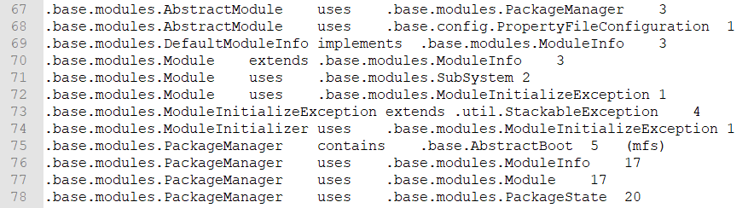

The source file can be manually created by the user or it can be created by a program as long as it meets these criteria.

## Selecting a source file.

The following information provides instructions on how to select a source file to run analysis.

### Open file explorer:

1. Run the program.
2. Click on “Select a file”.

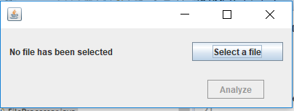

1. The “Open” window will be displayed.

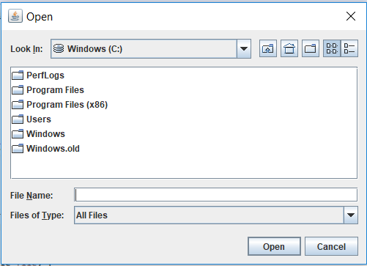

1. Navigate to your desired source file.

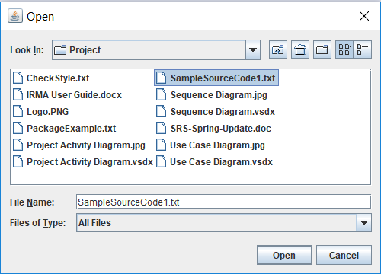

1. Select open.

6. The file location will now be populated in the window.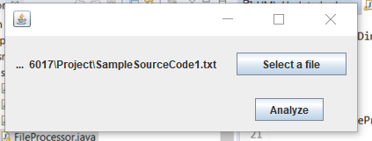

7. Select Analyze.

## Selecting Display Options

The analyze options window allows a user to choose from a variety of options explained below in fig. 1-1. The purpose of the display options is to provide a user with customization that will provide the maximum utility from the visualizations. The options also provide accessibility for users with disabilities through font and color options. These options will apply to the final visualization.

|  |  |
| --- | --- |
| Options | Definition |
| Font Size | The font size can be adjusted between 12 and 18. |
| Show Class Name | This option allows the user to show class name (checked) or to hide the class name (not checked). |
| Show Connection | This option allows the user to show class connections (checked) or to hide the class connections (not checked). |
| Font Color | White and black are the available font colors. |
| Class Color | Red and green are the available class colors. |

Figure 1-1: Display options available.

### Choosing display options:

1. Choose the options for the display.
2. Select font size between 12 and 18 from the drop down.

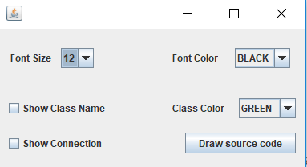

1. Choose to either show or hide class names.



1. Choose to show or hide connection.



1. Choose font color.



1. Choose class color.



1. Select “draw source code” button.



## Using the Visualization

The visualization shows nodes of different sizes base on the number of dependencies, the connections between the nodes and the names of the classes. The nodes are placed randomly on the screen and need to be arranged by the user to create a usable display. The user will simply click and drag the nodes to move them in the window. The connections will automatically update when the node is moved.

### Using the visualization:

1. Select a node that will be moved, click and drag to relocate it on the screen.

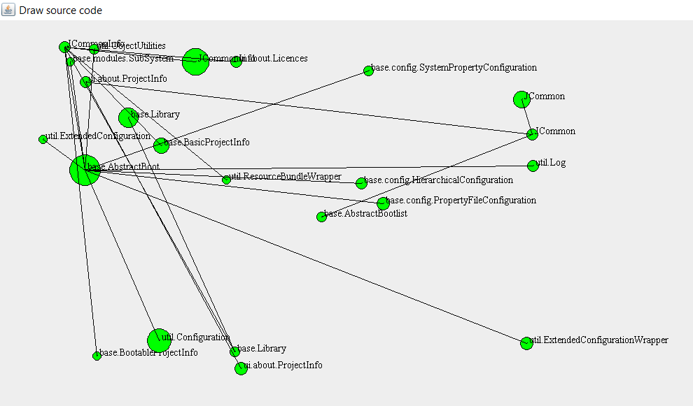

This area needs to be untangled🡪

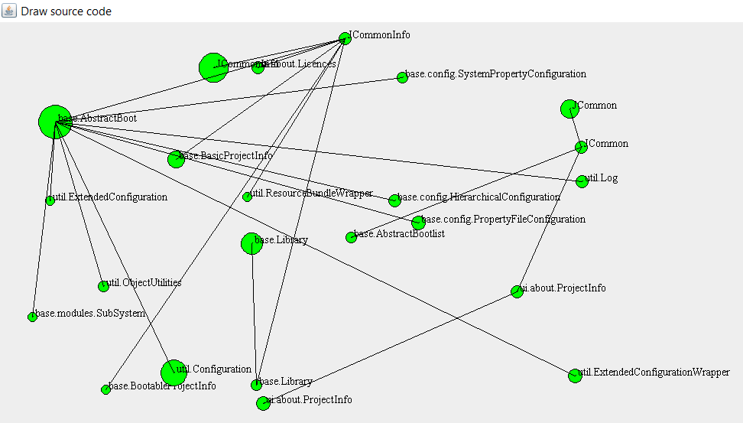

The nodes are more readable 🡪

2. Continue moving the nodes until the visualization meets the user needs.

